Schedule

Light snacks will be provided in each lodge during check-in.

Should you want to have dinner before you arrive, there are many restaurants off I-5 at exit 76 (the one before the exit to the retreat center) or at exit 82 in Centralia.

Friday
Check-in begins 5:30pm
Session 1 7:30pm

Saturday
Breakfast 7:30am
Session 2 9:30am
Break 10:45am
Lunch 12:30pm
Free Time until Dinner
Dinner 5:30pm
Session 4 7:00pm
Free Time 8:15pm

Sunday
Continental Breakfast 7:30am
Worship in Chapel 9:00am
Session 5 10:30am
Brunch 11:30am
Head Home 1:00pm

Psalm 23

The LORD is my shepherd, I shall not want.
He makes me lie down in green pastures;
He leads me beside quiet waters.
He restores my soul;
He guides me in the paths of righteousness
For His name’s sake.
Even though I walk through the valley of the
shadow of death,
I fear no evil, for You are with me;
Your rod and Your staff, they comfort me.
You prepare a table before me in the
presence of my enemies;
You have anointed my head with oil;
My cup overflows.
Surely goodness and lovingkindness will
follow me all the days of my life,
And I will dwell in the house of the LORD
forever.

Our Speaker

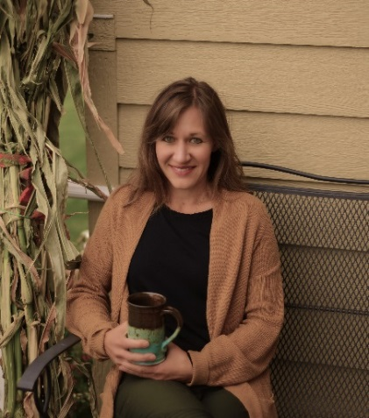
Dayna Martin is a teacher and writer who currently spends her days homeschooling and mentoring, cooking, cleaning and praying. Though she continually plots at becoming a professional with a lot of impressive titles, God keeps calling her to the mundane, ordinary tasks of caring for her family and those around her— a gift she doesn’t take for granted very often.

Whenever she can, though, she sneaks out to teach the Bible, embracing the opportunities that come her way. You can find her living in a loud and lively parsonage with her six kids in Williston, North Dakota, sitting in the front row of Liberty Evangelical Free Church listening to her husband preach, or maybe posting a tidbit on Instagram @dayna.l.martin.

Falls Creek
Retreat Center
Raymond, WA

Discover a place where you can truly “get away from it all”. Falls Creek Retreat Center is 157 acres of forest, meadows, streams and a beautiful waterfall. More than beautiful scenery far away from the hectic, urban pace, Falls Creek is a place to find rest and peace, renew faith and strengthen relationships.

From I-5, take Exit 77. Drive west on Highway 6 for 34 miles to milepost 19. Turn left onto Elk Prairie Road. Drive three miles and turn left on Falls Creek Road. Drive over the bridge and park by the office/conference center.

Bring
Bible, pen/pencil. Swimsuit for using the hot tub. Bedding and linens are provided. Watch your email for more information on what to bring.

Registration
January 27th, February 3rd and 10th, or at Bible Studies through February 5th.

Lodge: _____________________________
Roommates (if known): ______________
_____________________________________
_____________________________________

Activities Available

- Hot tub
- Hiking trails
- Games
- Puzzles
- Movies
- Horseshoes
- Tennis
- Crafts

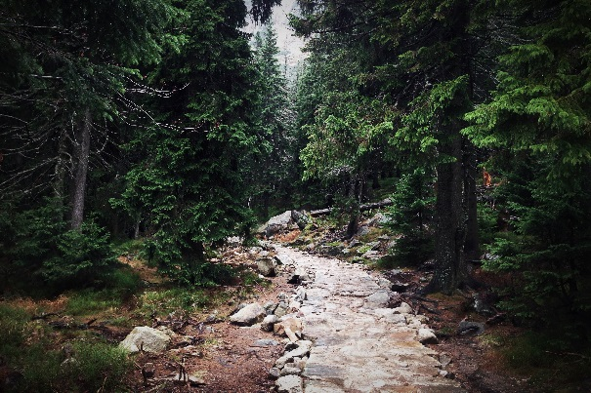

Cost: $165

Optional expenses not included in the registration fee are espresso bar, gift shop and selected crafts. Scholarships are available.

College-age and up are welcome!

Regrettably, lodging constraints do not accommodate nursing mothers.

Questions? Contact Michelle Jensen at mjensen@glenwoodcc.org or
503-473-4761.

Glenwood
Community Church

Women’s
Retreat

Life with the Shepherd

March 8 – 10, 2019

Falls Creek
Retreat Center
Raymond, WA

